For Managers & Approvers
Time Off Approval Workflow & Review Guide
SUMMARY
The purpose of this guide is to explain the leave approval process for direct managers and HR approvers. When employees submit time off requests, approvers receive automated email notifications containing full request details and a direct link to review the submission. Approvers can easily check leave details, verify balances and duration, and approve or refuse requests in single or two-stage validation workflows.
PROCEDURE
Step 1 – Approver receives email alert with request details and opens request.
Step 2 – Approver reviews employee, leave type, dates, duration, and reason.
Step 3 – Approver takes action: Click 'Approve' (or 'Validate') or 'Refuse'.
Step 4 – System sends automated notification to employee (and HR officer for 2nd approval).
APPROVER GUIDE
Step 1. Email notification: Reviewing new leave requests
Check your email inbox:
When an employee submits a leave request, you will receive an automated email: "Time Off Request: [Employee Name]".
The email includes a summary table showing:
• Employee: Name of the employee requesting leave.
• Leave Type: Category of leave (e.g. Paid Time Off, Sick Leave).
• From / To: Selected start and end dates.
• Duration: Calculated duration in days and hours (e.g. 2 days 4 hours).
• Description: Notes or reason provided by the employee.
Click the "View Request ->" button inside the email to open the request directly in Odoo.

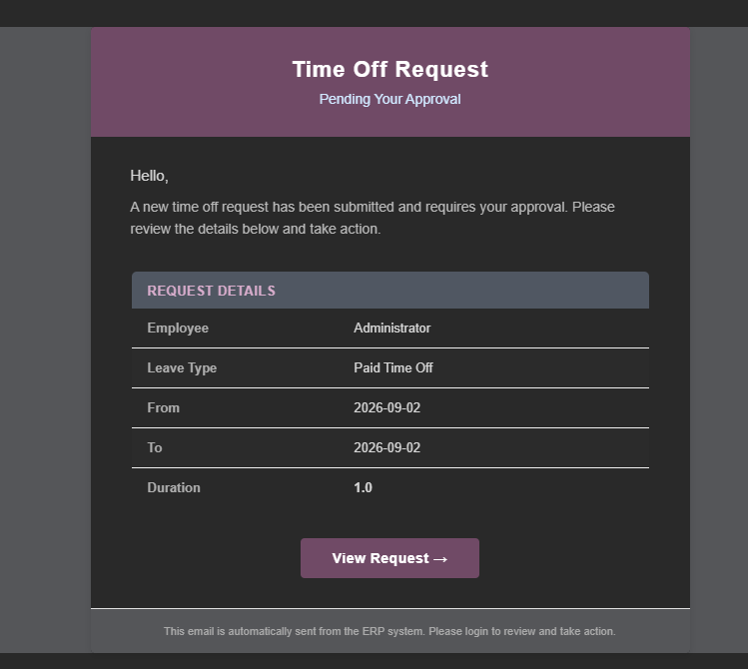
Step 2. Accessing pending requests in Odoo
You can also view all pending requests directly in Odoo without searching through emails:
Go to the "Time Off" app from the main menu.
Navigate to "Management" -> "Time Off" (or Approvals).
Filter the list by "To Approve" or "Second Approval Needed".
Click on any request to open and review the full details.
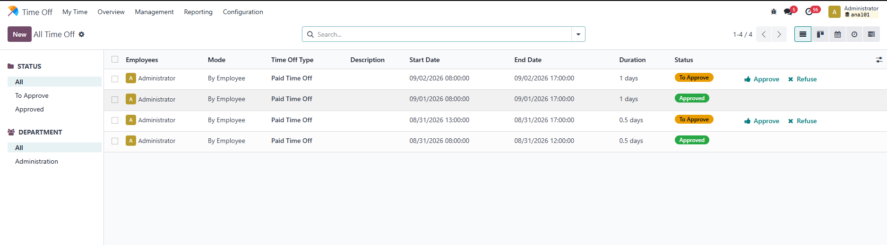

Step 3. Reviewing leave request details
On the leave request form, verify the following:
• Employee Name: Confirms who submitted the request.
• Leave Type: Ensures the correct leave category is selected.
• Dates & Duration: Displays the requested date range and computed work duration.
• Description / Reason: Review any explanation or attachments provided.
• Remaining Balance: Displays the employee's current available balance to ensure they have sufficient leave.
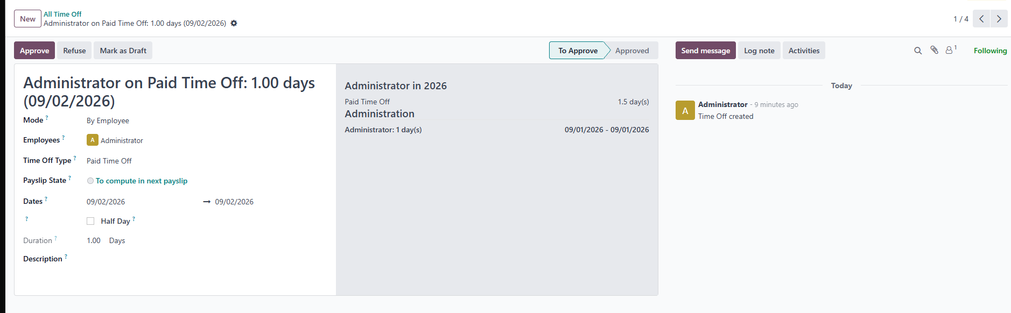

Step 4. Taking action: Approving or Refusing
1. To Approve a Request:
Click "Approve" (or "Validate") in the top action bar.
• Single-Step Approval: The request is validated immediately. The employee receives an email: "Time Off Approved".
• Two-Step Approval: Direct manager clicks "Approve" -> Status changes to "Second Approval Needed". The HR Officer receives an email alert and clicks "Validate" for final approval.
2. To Refuse (Reject) a Request:
Click "Refuse" in the top action bar.
The status changes to "Refused", and an automated email notification ("Time Off Refused") is sent to the employee.

Step 5. Understanding automated email notifications
The module manages all notifications automatically:
• Manager Notification: Sent to direct manager immediately upon employee submission.
• Second Approver Notification: Sent to HR Officer after direct manager approves (for 2-step leave types).
• Approval Confirmation: Sent to employee confirming the final approval.
• Refusal Notification: Sent to employee if the request is refused.

